PREFACE
I conducted my IPT (Industrial Practical Trainings) at Mbeya University Of Science and Technology) that gave me great chance to observe, learn, experience and practice the basics of Information and communication Technology in real life in short.
I had a chance of doing different tasks that I studied before in class that involved website designing and hosting from the ideas of different programming language

ACKNOWLEDGEMENT;
I would like to extend my grateful thanks to the almighty God for his grace, blessings, love and good health every day and during my Practical Training ,Also I would like to give a special thanks to my university computer lectures and facilitators (staff) ,friends and relatives who have been supporting me during all ten weeks of my Practical Training.
I am also grateful to Mbeya University of Science and Technology and all other staff members for accepting my request of conducting the practical training at Mbeya University of Science and Technology and most importantly for orienting me with the real work environment by letting me to be part of their team for the whole period of practical training .

Much thanks also goes to the chancellor of MUST allowing me to attend my field practical training at his institution, Also I would like to give a special thanks to my supervisor Mr. Edwin Nchia Together with Mr. George Kitula for their full cooperation during all weeks of practical training.

ABSTRACT
This field work attachment for the first year student was conducted at Mbeya University of Science and Technology from 10th July to 15th September 2023 where different activities were conducted and observed and were done in participatory way. Those activities include preventive maintenance and repair, configuration and programming Languages of different languages (HTML Language, CSS Language, JavaScript and PHP Language) and Database design.
The report also revealed the importance of practical training. In reality these Practical trainings are essential because they abide with three dimensions of learning which are cognitive, affective and psychomotor whereby they help one to integrate both of them in field through thinking, recalling, doing and feeling as well experiencing.

Practical Trainings are also advantageous because they shape one's behavior and make him/her learn from other staff members the ways of conduct and how to manage the working environment including the Way of dressing ,being organized ,respecting ,managing time and some time the way to speak during different Meetings(gatherings) which are conducted to specific institution or organization.

DECLARATION
I BONIFACE BEN SANKWA, am here to declare that the contents of this Technical report, are the original copy and also original design of what I went through in all my ten weeks of my Industrial/Field practical training. Also any of what explained within this report is true information especially when explaining more on among the different activities which were performed for ten weeks during Industrial/Field practical training period.

PART I GENERAL PART;

HISTORICAL BACKGROUND OF THE FIRM
In 1986, Mbeya Technical College (MTC) was established for the purpose of training students for the award Full Technician Certificate (FTC) under the Russian Training support. ... The long term plan was to transform Mbeya technical College into a University of Science and Technology through the University Act No.7 of 2005 and the Charter of Mbeya University of Science and Technology, 2013. Via nation council for technical education (NACTE) establishment order No.9 of and section 9 of the NACTE Act of 1997. MTC was officially launched on 1st September, 1986.
The transformation from MTC to MIST and the MUST was done to fulfill a long –term plan, made during the first phase Government, under the president of United Republic of Tanzania, the late Mwalimu Julius Kambarage Nyerere.
The Universities Act, requires Universities to draft Charters and have also required them to approved as a condition for providing University Education. In compliance with the requirements of the Universities Act, Mbeya University of Science and Technology has been established through part II, section 3(1) of the Mbeya University of Science and Technology Charter, (2013).

LOCATION
The university (MUST) is among the best universities we have in our country Tanzania. It offers many different engineering, science courses as well as some business courses.
Mbeya University of Science and Technology has two campuses. The Main Campus is located in Mbeya City in the Southern Highlands of Tanzania 10 km outside the city center and about 3 Km from the Mbeya – Tunduma Highway. The road to MUST branches from the highway at the Iyunga/Ituta -TAZARA area. The Rukwa Campus of Mbeya University of Science and Technology is located at Kianda along Tunduma Sumbawanga road, about 50 km from Sumbawanga.

A PICTURE OF MUST LOCATION



VISION;
The vision of Mbeya University of Science and Technology is to become the leading centre of excellence for knowledge, skills and applied education in Science and Technology.
MISSION;
The mission of Mbeya University of Science and Technology is to develop academically, technologically and socially competent students, staff and other stakeholders who will be responsive to the broader needs
And challenges of the society specifically by:
-Facilitating appropriate tuition, practical training and support according to the needs of students and other customers.

GRADUATION AWARDS FOR STUDENTS
-ORDINARY DIPLOMA PROGRAMMES
- Chancellor’s prize: Best Overall Finalist Student
-University Prize: Best Overall Finalist Female Student
-Note that Other Awards are to be set by the University
UNDERGRADUATE PROGRAMMES -Chancellor’s prize: Best Overall Finalist Student
-University Prize: Best Overall Finalist Female Student -Other Award to be set by the University
DEPARTMENTAL PRIZES
Other Prizes from departments may also be given to students based on criteria and award set by the departments.
OTHER PRIZES
Other Prizes from individuals or institutions may also be given to students based on criteria and award set by the donor.

MUST ORGANISATION STRUCTURE AND MANAGEMENT
Management of Mbeya University of Science and Technology (MUST)
Organization structure of Mbeya University of Science and Technology (MUST)
MANAGEMENT OF MBEYA UNIVERSITY OF SCIENCE AND TECHNOLOGY
- Vice Chancellor
Prof. Aloyce Mvuma - PhD (Dortmund) MSc. Eng. (UDSM), B.Eng. (Mysore),
- Acting Deputy Vice Chancellor Planning Finance and Administration (DVC-PFA
Dr Alexander Mtawa, PhD Mech. Eng. (CPUT, SA), Msc. Mech. Eng. (SOFIA, Bulgaria), FTC Mech. Eng. (ATC)

- Acting Deputy Vice Chancellor Academic Research and Consultancy (DVC-ARC)
Prof.Osmund Kaunde
- Principal of College of Engineering and Technology
Dr. Zacharia Katambara - PhD (WITS), MSc Eng. (UDSM) BSc Eng. (UDSM)
- Director of Human Resource Management
Mrs. Devotha Msuya - MSc.HRM (MZUMBE)
- Dean of School of Business Studies
Dr. Vicent Kipene – PhD (SUA), MBA(SUA), BSc Ed(SUA), Dip.Ed.(Monduli)
- Principal of College of Science and Education
- Director of Undergraduate Studies
- Dean of Students
Mr Augustine P. Matem - MA Ed. (UDOM), BSc Ed. (UDSM), Dip Ed. (Mkwawa)
- Chief Internal Auditor
Mr. Deusdedit Sinda - CPA (T), Diploma in accountancy (slet), ADA (IFM)
- Chief Accountant
Mr. Shwaibu Shaban - CPA (T), PGD Finance Management (IFM), ADA (IFM)
- Chief Planning Officer
Mr. Cornell Msemwa - MBA (SUA), BSc. FST (SUA)
- Director of Library Services
Mr. Novatus Luanda - MA. (UDSM), BA. (UDSM), Dip. (Nyegezi)
- Director of Postgraduate Studies, Research and Publication
- Director of MUST Consultancy Bureau (MCB)
Mr. Dua Chengula-PhD (Dortmund) MSc. Eng (UDSM) BSc. Civil (UDSM)
- Head-Center for Quality Assurance and Quality Control
Ms. Albentina Leonard, MBA-Finance &Banking (MZUMBE), BA. Ed (UDSM),
- Corporate Counsel
Advocate Saumu Mruke -LLM (Ruaha), PGD in Law (Law School of Tanzania), LLB (MZUMBE)

ORGANIZATION STRUCTURE OF MBEYA UNIVERSITY OF SCEINCE AND TECHNOLOGY
CHANCELLOR
ccccOUNCILsssssssss
VICE CHANCELLOR
HEAD OF INFORMATION, EDUCATION AND COMMUNICATION UNIT
DIRECTOR OF QUALITY ASSURANCE & QUALITY CONTROL
CHIEF INTERNAL AUDITOR
HEAD OF PROCUREMENT MANAGEMENT UNIT
HEAD OF LEGAL UNIT
DEPUTY VICE CHANCELLOR-ACADEMIC,RESEARCH AND CONSULTANCY
DEPUTY VICE CHANCELLOR-PLANNING,FINANCE AND ADMINISTRATION
PRINCIPALS/DEANS
ACADEMIC DIRECTORS
HEAD OF DEPARTMENT
ADMINISTRATIVE DIRECTORS
HEAD OF DEPARTMENT/SECTIONS

TECHNICAL PART:

INTRODUCTION
This part explains more on the Computer programming language, and services as one among the many activities during my Industrial/Field Practical Training at Mbeya University of science and technology (MUST).

COMPUTER PROGRAMMING LANGUAGES

The high-level language is a programming language that allows a programmer to write the programs which are independent of a particular type of computer. The high-level languages are considered as high-level because they are closer to human languages than machine-level languages. That is HTML, CSS, PHP, SQL and JAVA-SCRIPT
The high level programming is very important in website designing because of the following reason,
- The high-level language is easy to read, write, and maintain as it is written in English like words.
- The high-level languages are designed to overcome the limitation of low-level language, i.e., portability. The high-level language is portable; i.e., these languages are machine-independent.
WEBSITE DEVELOPMENT TOOLS.
In order to do any kind of website Coding we require TWO basic Software.
- TEXT EDITOR-Visual Studio Code
- WEBSITE BROWSER – Google Chrome, firefox, safari and chromium

Converting to machine language
Regardless of what language we use, eventually need to convert your program into machine language so that the computer can understand it. There are two ways to do this compile the program and interpret the program.
Compiled the program, this is done to transforms a program written in a high-level programming language from source into object code. Programmers or users write programs in a form called SOURCE CODE. Source code must go through several steps before it become an executable program. The first step is to pass the source code through a compile, which translates the high-level language instruction into object code and finally producing executable programs that the computer understands in the format uses.
Interpreter program is a program that executes instruction written in a high-level language. By starting with HTML programming language as my study during industrial practical training at Mbeya University of science and technology (MUST)

HTML (HYPERTEXT MARKUP LANGUAGE)
HTML stand for Hypertext Markup language, A markup language is a set of markup tags, Each HTML tags are describes by different document contents and this HTML documents are described by HTML tags. HTML is a basic of all programming languages as a standardized system for tagging text files, to achieve font, color, graphic and hyper link effect on the world wide web pages, that usefully in website and system design and developments specifically for the students who are taking computer course for their field of life in such a way that described below;

Example of HTML documents
The DOCTYPE declaration defines the documents type to be HTML
The text in between <html> and </html> describes an HTML
The text between<head> and </head> provides information about documents
The text in between <title> and </title> provides a title for the document
The text between <body> and </body> describes the visible page content
The text between <h1> and </h1> describes a heading
The text between <p> and </p> describes a paragraph
Using this description, a web browser can display a document with a heading and a paragraph, the purpose of a web browser (Google chrome, Firefox, Safari) is to read HTML documents and display the contents

HTML Tags
HTML tags are Keywords (tag names) surrounded by angle brackets, the start tag is often called the Opening tag and the end tag is often called the closing tag.
<tag name> content </tag names>
- HTML tags normally come in pairs like <p> and </p>
- The first tag in a pair is the start tag, the second tag is the end tag
- The end tag is written like the start tag, but with a slash before the tag name

HTML Page Structure
Below is a visualization of an HTML page structure, which can be written using sublime text, atom, visual code and text editor. For instance by using visual code step should be followed are described below;
Step 1: Open Visual studio Code
To open visual code in window 7, 8 or 10, Click start button (left on your laptop screen). Click all programs. Click Accessories and then click visual code.

Step 2: Write HTML content and Tags
After opening visual code plane part is where all content goes there in a logical grammatical rule of computer programming language. Anything it can be written, concerning with any task needed to be performed. and it is written in the order of how programming is being written.
Below is a simple example on how the information can be written on the visual code.
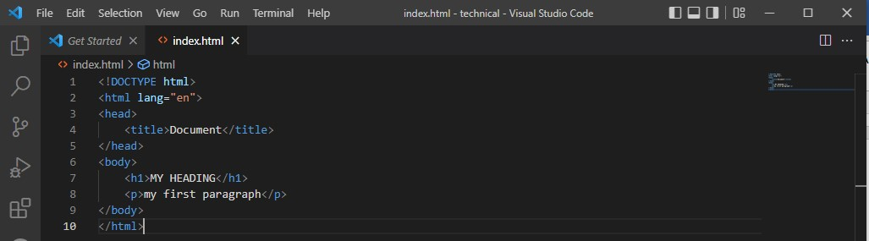

Step 3: Save HTML Page
Saving of the file on the computer for the further use by selecting > Save as in the visual code menu then name of the file “index.html” or any other name ending with html or html. 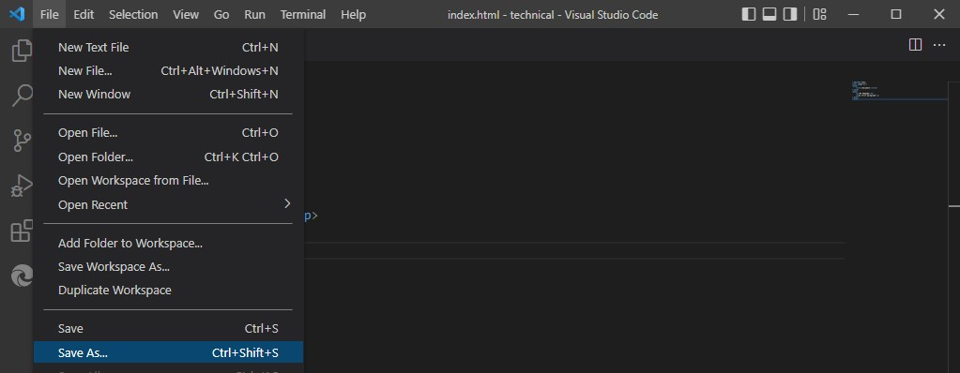

Step 4: View HTML Page in browser
Open the Saved HTML file in the favorite browser (Google chrome, Firefox, Safari and chromium). Using this description, a web browser can display a document with a heading and a paragraph, the purpose of a web browser is to read HTML documents and display the contents

The browser does not display the HTML tags, but uses them to determine how to display the document for example is shown below, the result will be displayed like this,
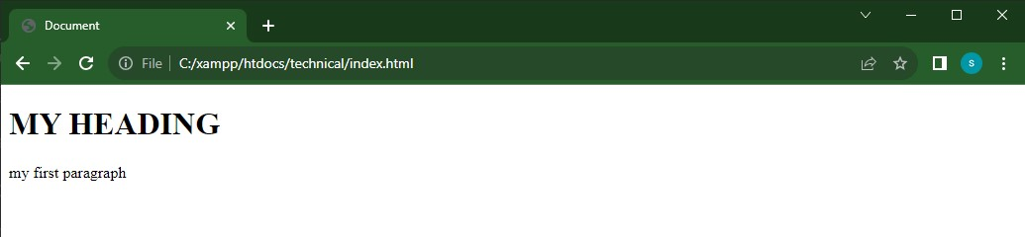

Note: To open a file in a browser, double click on the file, or right-click, and choose open with.
CSS (CASCADING STYLE SHEET)
CSS stand for Cascading Style Sheet which used to format the layout of web pages. They can be used to define text style, table size, and other aspect of web pages that previously could only be defined in page’s HTML. Also describes how HTML elements are to be displayed on screen, paper or in other media and control the layout of multiple web pages all at once, External style sheets are stored in CSS files.
CSS help web developers create a uniform look across several pages of a web site, instead if defining the style of each block of the text within a page’s HTML, commonly used style need to be defined only once in a CSS document. Once the style is defined in cascading style it easier to change style across several pages at once. For example, a web developer may want to increase the default text same style sheet, the text size only needs to be changed on the style sheet and all the pages will show the will show the larger text.
Its helpfully for formatting other aspects of web page layout as well, for example, CSS can be used to define the cell padding of the table cells, the style, thickness, and color of a table’s border, and the padding around image or other objects. CSS gives web developers more exact control over web pages will look than HTML does.

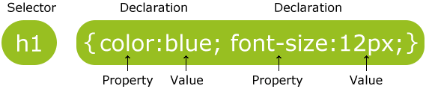

The selector point to the HTML element you want to style,
The declaration block container one or more declarations separates by semicolons
Each declaration includes a CSS property name and a value, separated by a colon,
A CSS declaration always ends with a semicolon, and declaration blocks are surrounded by curly braces.
When a browser reads a style sheet, it will format the HTML document according to the information in the style sheet.
There are three way of inserting CSS
1. External style sheet
2. Internal style sheet
3. Inline style

External style sheet, each page must include a reference to the external style sheet file inside the <link> element, the<link> element goes inside the <head> section as shown below

<head>
<link rel="stylesheet" type="text/css" href="mystyle.css">
</head>

Internal style sheet, are defines within the <style> element, inside the <head> section of an HTML page as shown below
<head>
<style>
body {
background-color: linen;
}
h1 {
color: maroon;
margin-left: 40px;
}
</style>
</head>
Inline style sheet used to add the style attribute to the relevant element. The style attribute can contain any CSS property, which has highest priority for style definition. For example shown below
<h1 style="color: blue; margin-left: 30px ;"> this is a heading.</h1>

<p style=" padding: 0 auto; text-align: center ">my name is MUST.<p>

HTML was NEVER intended to contain tag for formatting a web page, HTML was created to describe to the content of a web page, like
<h1>this is heading </h1>
<p>this is paragraph </p>
When the tags like <font>, and other attributes were added to the HTML Specification, the style definition are normally saved in the external. CSS files. With an external style sheet file, you can change the look of an entire website by changing just once file.
After having the good understanding of HTML and CSS I create simple page using HTML and CSS as shown below.
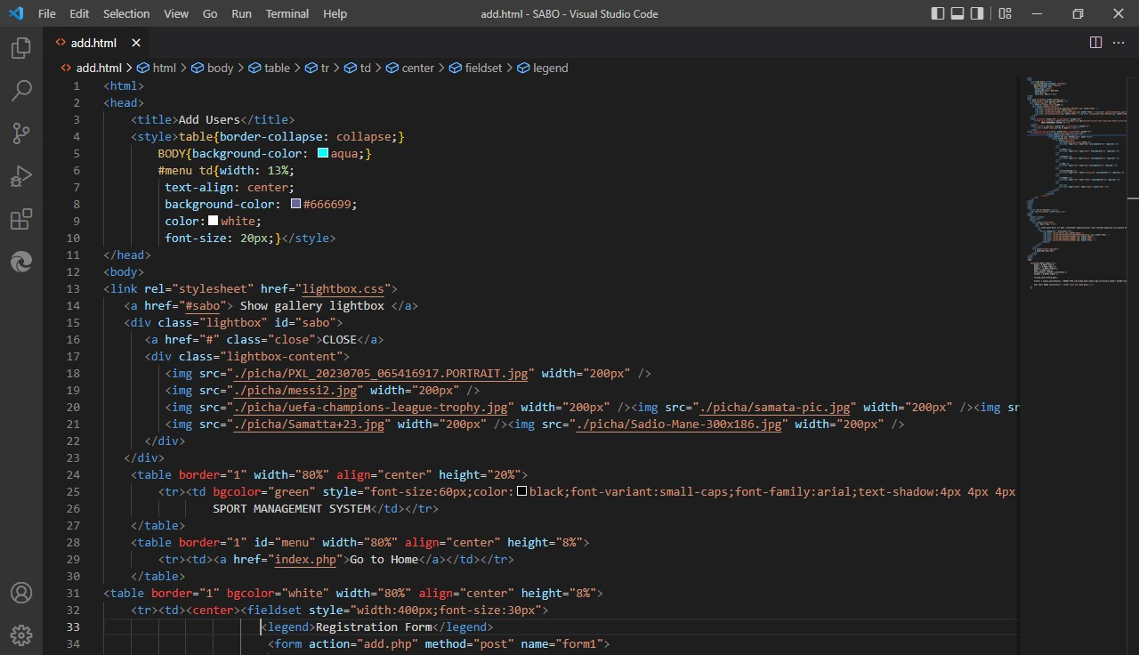

The above written text produces an output to web browser as shown below

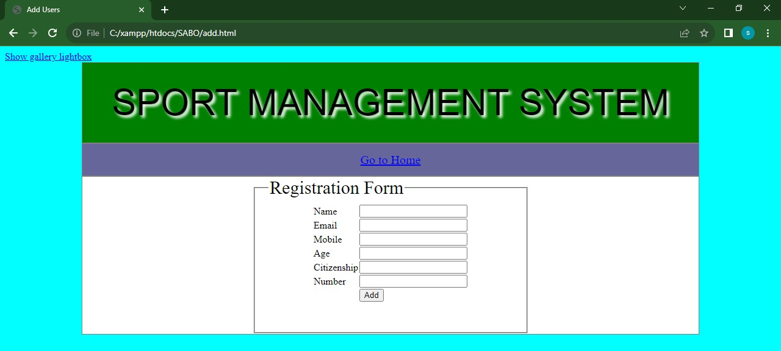
JAVASCRIPT AS A PROGRAMMING LANGUAGE
JavaScript is one of the three languages all web developers must learn. This JavaScript is the most popular programming language in the world
- HTML to define the content of web pages
- CSS to specify the layout of the web page
- JavaScript to program the behavior of the web pages
JavaScript can change HTML content
One of many HTML method is getElementById (), for example below shown the use of method to find an HTML element (with id=”name”), and changes the element content (innerHTML) to “Hellow JavaScript”;
Document. GetElementById ("demo"). InnerHTML = "Hello my Dady";
JavaScript also can change HTML Style (CSS), changing of the HTML content, is variant of the changing of an HTML attribute. For instances shown below
Document. GetElementById ("demo"). style.fontSize = "20px";
Also JavaScript can be placed in the <body> and<head> section of HTML page. In HTML, JavaScript code must be inserted between <script> and </script> tag
<Script>
document. GetElementById ("demo"). InnerHTML = "My First JavaScript";
</script>

JAVASCRIPT FUNCTIONS AND EVENTS
A JavaScript function is block of JavaScript code, that can be placed when asked for, for example, a function can be executed when an event occur, like when the user clicks a button. You can place any number of script in an HTML document in the < body>, or in the <head> section of an HTML page, or in the both. But it is good idea to place script at the bottom of the < body>element, this can improve page load, because script compilation can slow down the display.
Note: JavaScript does NOT have any built-in print or display function.

JAVASCRIPT DISPLAY POSSIBILITIES
JavaScript can “display” data in different ways where everyone has its own function in term of execution of the output data.
- Writing into an alert box, using window. Alert ().
- Writing into the HTML output using document. Write ().
- Writing into the browser console using console.log ().

SQL (STANDARD QUERY LANGUAGE)
SQL stand for Standard Query language for accessing and manipulating databases such that MYSQ, ORACLE and other database systems.
In my Industrial Practical Training at Mbeya University of science and technology I learn how to create, update, delete, view data from the database after creating by having many blogs including databases where I gain more knowledge about it. Not only that but also to all my project and study concerning with Information and Communication Technology

ADVANTAGE OF LEARNING SQL IN MY REAL LIFE
- SQL can execute queries against a database
- SQL can retrieve data from a database
- SQL can easier insertion of records in the database
- SQL can easier update record in the database
- SQL can create new databases
- SQL can delete record from the databases
- SQL can create new table in a database
- SQL can create stored procedures in a database
- SQL can create views in a database
- SQL can set permission on table, procedures, and Views
The presence of the database such that MYSQL can often contain one or more table according to the record that you want to keep in it. In my leaning I was using MYSQL where in order to access I do installation of XAMPP CONTROL PANEL, after installation completed, I click window button and type Xampp control panel and then should firstly turned on APACHE and MYSQL as shown below
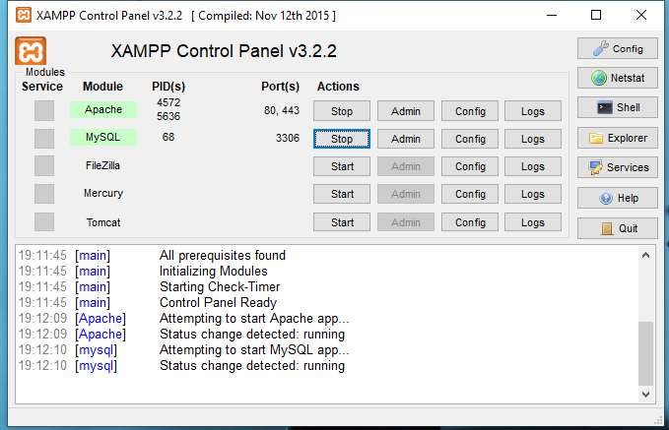
And then typed localhost/phpMyAdmin/ in the Google chrome browser and display likes this
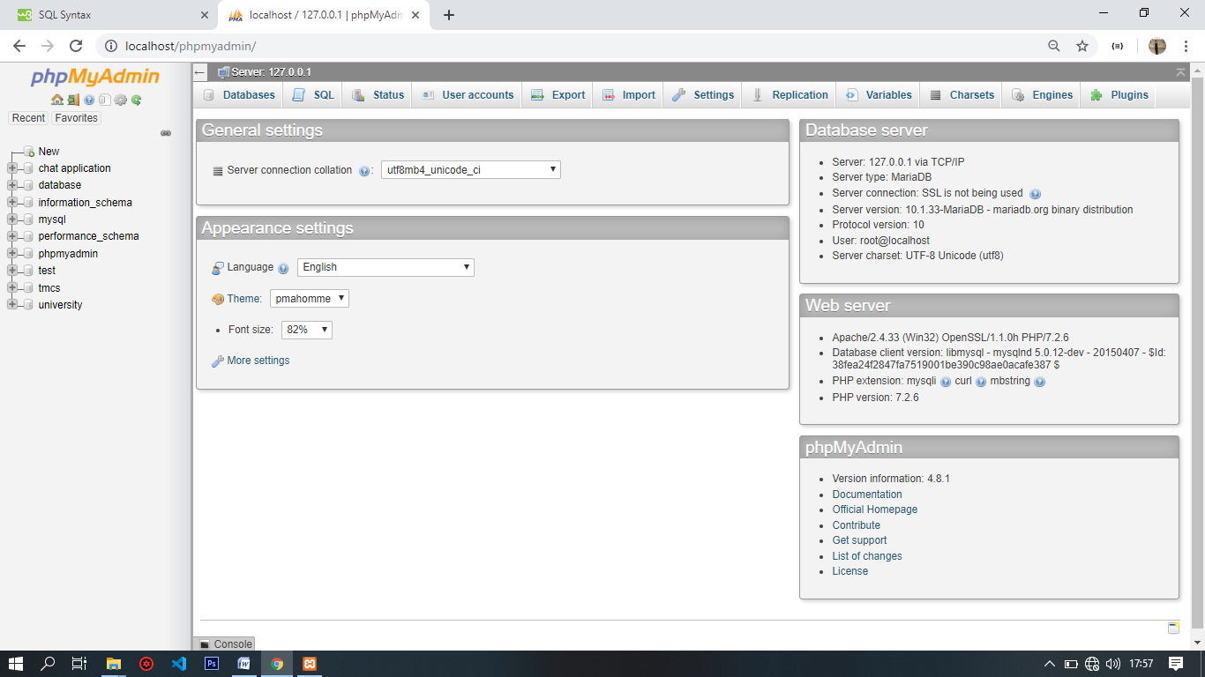
Where each table is identified by name after creating name of database with name of table for example customer table, University table and other name according to information you may want to store or keep. Below is the example shows a customer table,
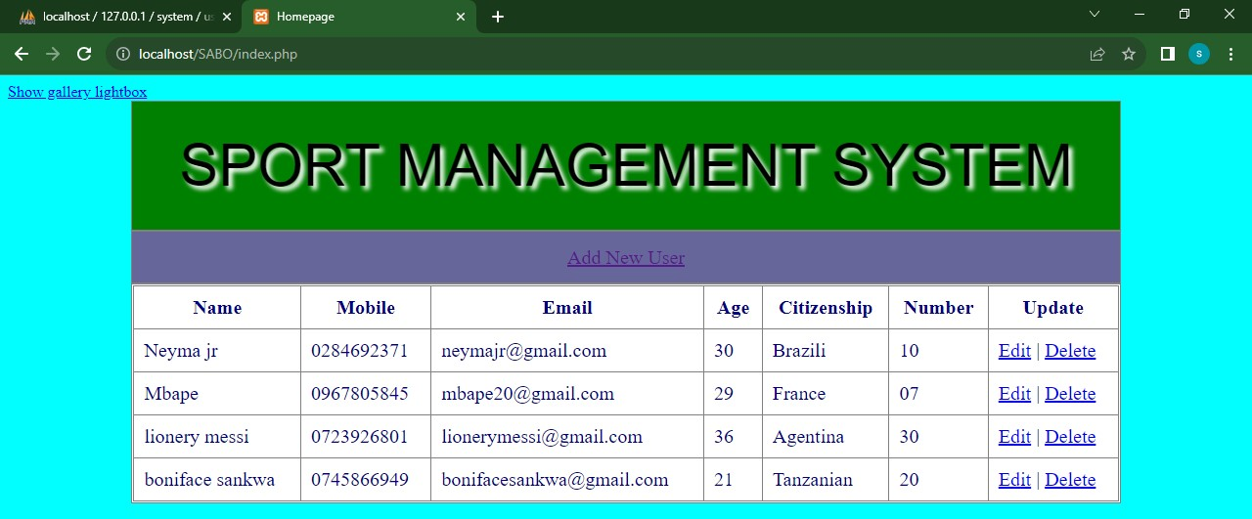
The following are the most SQL statement that I learn during my industrial practical Training at Mbeya University of science and technology with my aid of supervisor Mr. Edwin Nchia and my supporter Mr. George Kitula as follows
- SELECT – extract data from a database
- READ-read data from the table
- UPDATE- updates data in a database
- DELETE- deletes data from the database
- INSERT INTO- insert new data into a database
- CREATE TABLE- create a new table in the database
- CREATE DATABASE – create a new database
- ALTER TABLE- modifies a table from the database
PHP (HYPERTEXT PREPROCESSOR)
PHP is a server scripting language, and a powerful tool for making dynamic and interactive web pages and its open source scripting language that are executed on the server.
PHP file can contain text, HTML, CSS, JAVASCRIPT and PHP code which are executed on the server and the result is turned to the browser as plan HTML, and has extension of “.php”
Mainly purpose of using PHP in every system and website are as follows
- PHP can generate dynamic page content
- PHP can create, open, read, write, delete, and close files on the server
- PHP can collect form data
- PHP can send and receive cookies
- PHP can add, delete, modify data in database
- PHP can be used to control user-access
Note: With PHP are not limited to output HTML, you can output image, PDF files, and even Flash movies. You can also output any text, such as XHTML and XML
BASIC PHP SYNTAX
PHP can be placed in the document, A PHP script start with <? PHP and end with?>where PHP are not case sensitive. However, all variable names are case-sensitive
</php
//PHP code goes here
?>
The default extension of PHP is .PHP file normally contains HTML tags, and some PHP scripting code, Below are example of a simple PHP file, with a PHP scripting that uses a built-in PHP function “echo” to output the text “Hello world” on a web page:
<! DOCTYPEhtml>
<html>
<body>
<h1>My first PHP page</h1>
<? php
echo "Hello World!";
?>
</body>
</html>
HOSTING OF WEBSITE PAGE
Finally, after learning how to use different interactive language to a certain website and system, Hosting is a location where people store their website to access it. The location consists of the system and internet connection, hardware and software in order to provide services to the user. Also we learn how to host this page when you want to make all a user can have a fully access on it, by creating the domain name that can simplify a user to access the page, and the hosting site can be CPANE or any else.

RECOMMENDATION AND CONCLUSION...
Recommendations
Generally, the field place was good and it has conducive place for learning and acquisition of new knowledge for other learners but there are some challenges which faced me during my field studies. Those challenges are;
- Working time is too long compared to the tasks and activities logged on per day. Sometimes few hours may pass without doing any task so that much time can be spent in other personal activities.
- There is overlapping of authority.
- Interruption during working time especially many work at once.

Conclusion
On above explanation to my industrial practical training at Mbeya University of science and technology many things learned to cooperate with people and performing concrete job as a ICT learner and on how to afford problems.
From the challenges mentioned above the organization of MBEYA UNIVERSITY OF SCIENCE AND TECHNOLOGY (MUST) should solve this problems so that to ensure and keep maintaining their developing activities.
My advice toward those challenges is this, if it is possible for management and Department to minimize working hours so that much time could be used for doing particular tasks and not personal tasks. All workers should work under their authority and avoid working overlapping..

TABLE OF CONTENTS
PREFACE 1
ACKNOWLEDGEMENT; 1
ABSTRACT 1
DECLARATION 2
PART I GENERAL PART; 3
HISTORICAL BACKGROUND OF THE FIRM 3
LOCATION 3
VISION; 4
MISSION; 4
GRADUATION AWARDS FOR STUDENT…………………………………………….4-5
MUST ORGANIZATION STRUCTUER AND MANAGEMENT………………………5-7
PART II TECHNICAL PART 8
INTRODUCTION 8
COMPUTER PROGRAMMING LANGUAGE 8
HTML(HYPER TEXT MARKUP LANGUAGE)…………………………………………9-11
CSS(CASCADING STYLE SHEET……………………………………………………11-14
JAVASCRIPT AS A PROGRAMMING LANGUAGE……………………………………………………………………………….15-16
STANDARD QUERY LANGUAGE…………………………………………………………………………………………………………16-18
PHP(HYPERTEXT PREPROCESOR) 19
HOSTING OF WEBSITE 20
RECOMENDATION 20
CONCLUSION…………………………………………………………………………………………………………………………………………21

